

**SCHOOL OF PHYSICS**

**UNIVERSITI SAINS MALAYSIA**

**ZCT191/192 PHYSICS PRACTICAL I/II**

**1OS3 GEOMETRICAL OPTICS**

***Lab Report***

[Full Name] ([matric number])

Abstract

[The abstract is a summary of your lab report, emphasising on what this experiment is about, its list of objectives, and the conclusions. The abstract is written only in a single paragraph, the paragraph is specially indented, and usually not more than 350 words. Be quantitative with your conclusion, e.g. the value of focal length is $20.0±0.1 cm$, within $3\%$ experimental uncertainty, etc. You can overwrite these placeholder texts, but remember to remove the square brackets when you do so!]

Introduction and Theory

[This section is for you to introduce what this experiment is about, and explain the important theoretical knowledge that is needed to explain your methodology, results and conclusion. This section need not be long, most of the info you need can be found in your lab manual and can be synthesised. Remember to paraphrase the text you copied: note that the lab manual was written in *instructive form* (‘remember that’, ‘recall that’), and since you are merely reporting your work, you should edit the language suitable for reporting.]

[You should include important equations that could help to explain the physical theories better to your reader. Always use the *Microsoft Equation Editor* (shortcut: alt+=) to format your equations. The following row is an example of a numbered equation (**Equation 1**), you can copy and paste this row all across your report to number your equations. Always provide definitions of variables appearing in your equations in the paragraph.]

|  |  |  |
| --- | --- | --- |
|  | |  |

[You should also include figures in your report to summarise concepts or methodologies. At this stage, providing captions for your report is not compulsory, but it will be a good practice to start. Always ensure that your image is of high resolution, centred, appropriately sized, and if you have a caption, it should have a smaller font size than the text. Always remember to mention the figure in your paragraphs. An example is shown in **Figure 1** below.]

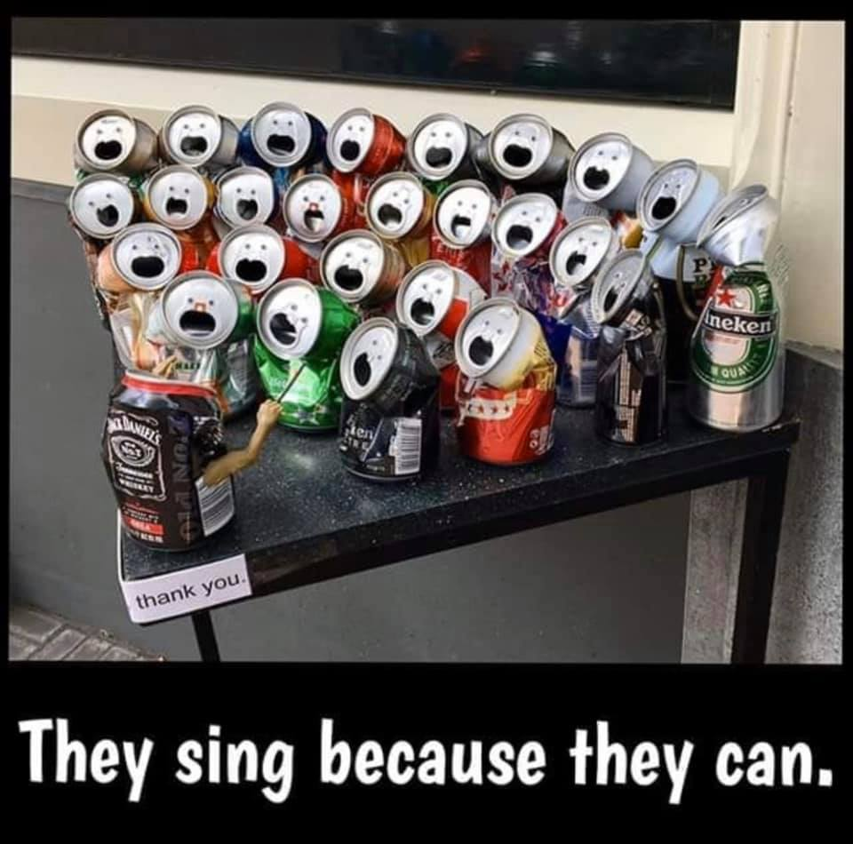

**Figure 1**: they sing because they can.

[You should end this section by restating the objectives of the experiment, and have a brief mention of what will be discussed in the following sections will be about.]

Experimental Methodology

[This section is for you to tell us what you did, so it is written in *passive form* (‘the lens was placed’, ‘the experiment is repeated’), and neither in *instructive form* nor *point form*. Summarise the methodology, one paragraph for each section, and provide at least one image of your equipment used (you don’t need to list down all the equipment or materials).]

[On top of summarising how the experiment is conducted, you should also mention what you did to the data collected after that, e.g. ‘a plot of *y* vs *x* was plotted’, ‘the gravitational constant was calculated’, etc.]

[Formatting tips: a variable is always *italicised* ($g$, $σ$, etc), while a unit is always straight (cm and not ‘*cm*’), do take note!]

Results and Data Analysis

[This section is for you to tabulate all the results that you have obtained in your experiment. Basically you will need to answer all the questions found in the **Analysis** sections in your lab manual, not in point form, but in paragraphs separated by sections. You don’t need to copy paste your full Excel table here (the full table should be attached at the end of the report), but you can create your own summary tables of the major results you have obtained from the experiment.]

[It is important to write your quantitative values clearly, with the correct number of significant figures and uncertainties (when applicable). Workings and calculations are not required here, just mention that you have done your calculations using Microsoft Excel, and tabulate the results here. It is important to explain your results in words; don’t just put many terms and equations without explanation. If you have a graph, it belongs here, and ensure that the axes labels, title, error bars, regression line and equations are clearly seen.]

[Quantities to consider when analysing your results: (1) accuracy of quantity measured (percentage discrepancy), (2) precision of data collection (fractional uncertainty), (3) consistency between different experiments (percentage difference), (4) error bars and uncertainties calculated, and (5) correlation between variables (correlation coefficient).]

[Formatting tips: the captions of tables are usually *above* the table, while captions of figures are usually *below* the figure. Tables can have smaller font sizes to prevent the table from taking too much space in the report. An example is shown in **Table 1** below.]

**Table 1**: caption of the table.

|  |  |  |
| --- | --- | --- |
| **Header** | **Header** | **Header** |
| Data | Data | Data |

Discussion

[The discussion section is for you to make a further discussion of your results, it is usually comprised of three parts: (1) you discuss how are your uncertainties and error bars calculated (propagation of errors), and discuss if the values obtained are reasonable; (2) you discuss the possible mistakes or errors you made in the experiment (outlier data, precautions not taken), and how it could have been done better; and (3) out-of-the-box discussions: what other results could be derived, what other methodologies could be included, challenging the existing methodology, the limitations of the experiment, etc. The output of this section usually separates the excellent and mediocre students.]

Conclusion

[Conclude your experiment by answering the objectives of this experiment, quantitatively.]

# References

[List down the documents you have referred when writing this report. Always remember to include author name (last name, first name), year, title of document, publisher/organisation and link, whenever possible. If no author name is found, you can replace it with the organisation name or the website domain name (e.g. mysa.org). The following are some examples:]

Soo, J. Y. H., Al Shuaili, I. Y., and Mahmud Pathi, I. (2023). *Machine Learning Applications in Astrophysics: Photometric Redshift Estimation.* AIP Conference Proceedings 2756 040001, <https://doi.org/10.1063/5.0140152>.

Soo, J. Y. H. (2023). *1OS3 Geometrical Optics Lab Manual.* Universiti Sains Malaysia.

HyperPhysics (n. d.). *Thick Lens Imaging*. Georgia State University. <http://hyperphysics.phy-astr.gsu.edu/hbase/phyopt/thinfilm.html>.

# Appendix

[Use this section only if you have any extra-long tables or extra-large graphs you want to put in this report, but couldn’t fit the results or discussion section. Otherwise, you can remove this heading and placeholder text altogether. Remember to convert this document into a PDF file, then attach your Microsoft Excel worksheet at the end of the PDF file.]